Chapter 1
Fundamental of Computer Design

- What is a computer system?
Computer system is a collection of Central Processing Unit, memory system and peripheral devices, all interconnected by groups of conductors called buses.
A computer system allows users to input, manipulate and store data. Computer systems typically include a computer, monitor, keyboard, mouse and other optional components. All of these components also can be integrated into all-in-one units, such as laptop computers.
During the data processing stage, instruction sets, known as programs, are provided to let the system know what to do with the entered system data. Without these programs, the computer would not know how to process data that enters the system, and the data might be discarded. Known as a stored program computer, this type of computer is the most common in use today. It is very flexible, as it can process any task by loading a program from storage. Computer systems can work by themselves or access other devices that are external or connected with other computer systems.

What is the difference between computer architecture and computer organization?
Computer Architecture is abstract model and are those attributes that are visible to programmer like instructions sets, no of bits used for data, addressing techniques.
A computer's organization expresses the realization of the architecture. OR how features are implemented like these registers, those data paths or this connection to memory. contents of CO are ALU, CPU and memory and memory organizations. It is also called micro architecture.
The difference lies, precisely, between the “What” and the “How” .
Computer Architecture is the “What”.
Computer Organization is the “How”.
CA tells you what the system does. So, knowing about the architecture is basically knowing what functionalities will your system display. What you can expect to get out of it.
CO tells you how exactly all units in your system have been arranged and interconnected to help realize the architectural goals your system claims to have achieved.
Their differences can be tabulated as follows:
Computer Architecture | Computer Organization
1. Comp architecture is concerned with the structure and behavior of comp system as seen by the user. | 1. Computer organization is concerned with the way the hardware components operate and the way they are connected together to form computer system.
2. It includes information, formats, instruction set and techniques for addressing memory. | 2. It includes Hardware details transparent to the programmer such as control signal and peripheral.
3. It describes what the computer does. | 3. It describes how the computer performs.
4.Example: instruction set, addressing modes | 4.Example: circuit design, control signals, memory types this all are under computer organization.
5. Can last for longer times | 5. may changes soon and can have multiple organization for single architecture

- Discuss computer design cycle.
The computer design and developments have been under the influence of:
- Performance
- Cost
- Technology



The new trends in technology have been used to reduce the cost and enhance the performance. The computer design evaluated for bottlenecks using certain benchmarks to achieve the optimum performance.
Time is the key measurement of performance: a desktop user may define the performance of his/her machine in terms of time taken by the machine to execute a program; whereas a computer center manager running a large server system may define the performance in terms of the number of jobs completed in a specified time.
The desktop user is interested in reducing the response time or execution time – time
between the start and completion of an event; while a data processing center in
increasing the throughput.
Benchmarks are the programs which try to average frequency of operation and operands of a large set of programs. Standardized benchmarks tools are available from Standard Performance Evaluation Corporation – SPEC at www.spec.org. Simulation at different levels of design abstraction, such as: ISA, RT, Gate, Circuit is done to evaluate the performance for different levels of workloads. It helps in keeping the result verification cost minimum.
1: Technology Trends: Computer Generations
The technology trends at different times in the history of the computer development have played major role in the journey of computers form uniprocessor to multiprocessor mainframe systems; and from super structure to desktop computing.
Usually identified by dominant implementation technologies, the length of first three generations spreads over a period of 8 to 10 years.
- The first generation, 1950-59, is the era of commercial electronic computers employing vacuum tube technology.
- The second generation, 1960-68, is the period of cheaper computers made using transistor or discrete component technology.
- The third generation, 1969-77, is the age of minicomputers developed employing integrated circuit technology.
- The fourth generation, 1978 to date, the eon of personal computers and workstations, is the result of VLSI and ULSI technology.
- The gateway to the fifth and higher generations is not clear as no revolutionary technology has been proclaimed.
The present transistor technology has developed to an extent where up to 15 million transistors are integrated on one VLSI chip to make PowerPC and Pentium Processors. In 1980, the performance of supercomputers was 50 times that of microprocessor, 20 times of minicomputers and 10 time that of mainframe computers. The performance of microprocessors was equivalent to that of supercomputer in 1992 and it was much higher in 1995 and onwards
3: Cost
The systems are implemented using the latest technology to obtain cost effective high performance solution. Implementation complexities are given due consideration.
Price Verses Cost
• The relationship between cost and price is complex one
• The cost is the total amount spends to produce a product
• The price is the amount for which a finished good is sold.
• The cost passes through different stages before it becomes price.
• A small change in cost may have a big impact on price

Component Costs
• Direct Costs (add 25% to 40%) recurring costs: labor, purchasing, scrap, warranty
• Gross Margin (add 82% to 186%) nonrecurring costs: R&D, marketing, sales, equipment maintenance, rental, financing cost, pretax profits, taxes
• Average Discount to get List Price (add 33% to 66%): volume discounts and/or retailer markup

Thus, computer design and development has been under the influence of technology, performance and cost; the decisive factors for rapid changes in the computer development have been the performance enhancements, price reduction and functional improvements. The new trends in technology are used to enhance the performance and reduce the cost.
- What is significance of Amdahl's Law?
It is named after computer scientist Gene Amdahl( a computer architect from IBM and Amdahl corporation), and was presented at the AFIPS Spring Joint Computer Conference in 1967. It is also known as Amdahl’s argument. It is a formula which gives the theoretical speedup in latency of the execution of a task at a fixed workload that can be expected of a system whose resources are improved. In other words, it is a formula used to find the maximum improvement possible by just improving a particular part of a system. It is often used in parallel computing to predict the theoretical speedup when using multiple processors.
Speedup-
Speedup is defined as the ratio of performance for the entire task using the enhancement and performance for the entire task without using the enhancement or speedup can be defined as the ratio of execution time for the entire task without using the enhancement and execution time for the entire task using the enhancement.
If Pe is the performance for entire task using the enhancement when possible, Pw is the performance for entire task without using the enhancement, Ew is the execution time for entire task without using the enhancement and Ee is the execution time for entire task using the enhancement when possible then,
Speedup = Pe/Pw
or
Speedup = Ew/Ee

Amdahl’s law uses two factors to find speedup from some enhancement –
• Fraction enhanced – The fraction of the computation time in the original computer that can be converted to take advantage of the enhancement. For example- if 10 seconds of the execution time of a program that takes 40 seconds in total can use an enhancement , the fraction is 10/40. This obtained value is Fraction Enhanced.
Fraction enhanced is always less than 1.
• Speedup enhanced – The improvement gained by the enhanced execution mode; that is, how much faster the task would run if the enhanced mode were used for the entire program. For example – If the enhanced mode takes, say 3 seconds for a portion of the program, while it is 6 seconds in the original mode, the improvement is 6/3. This value is Speedup enhanced.
Speedup Enhanced is always greater than 1.
The overall Speedup is the ratio of the execution time:-
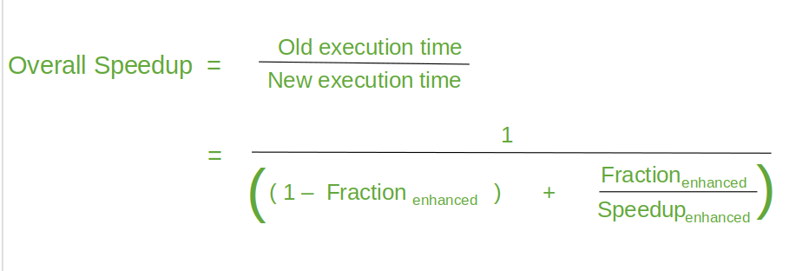
Proof :-
Let Speedup be “S”, old execution time be “T”, new execution time be “T'”, execution time that is taken by portion A(that will be enhanced) is “t”, execution time that is taken by portion A(after enhancing) is “t'”, execution time that is taken by portion that won’t be enhanced is “tn”, Fraction enhanced is “f'”, Speedup enhanced is “S'”.

Now from the above equation,
S = T/T’
T = tn + t
T’ = tn + t’
f’ = t/T
= t/(t + tn)
1 – f’ = 1 – (t/(t + tn))
= tn/(t + tn)

S’ = t/t’
t’ = t/s’
= (T * f’)/S’ [bcoz f’ = t/T]
= ((tn + t) * f’)/S’
t’/(tn + t) = f’/S’

S = T/T’
= (tn + t)/(tn + t’)
= 1/((tn + t’)/(tn + t))
= 1/((tn/(tn + t)) + (t’/(tn + t))

S = 1/(1 – f’ + (f’/S’))

Overall Speedup = 1/(1 – fraction enhanced + ( fraction enhanced/Speedup enhanced )
Example 1: Suppose that we are considering an enhancement to the processor of a server system used for web serving. The new CPU is 10 times faster on computation in the web serving application than the original processor. Assuming that the original CPU is busy with computation 40% of the time and is waiting for I/O 60% of the time, what is the overall speedup gained by incorporating the enhancement?
A N S W E R
Fractionenhanced = 0.4
Speedupenhanced = 10
Speedupoverall = = ≈ 1.56

Example 2: Floating-point (FP) operations consume 50% of the execution time of a graphics application. FP square root (FPSQRT) is used 20% of the time.
    - Improve FPSQRT operation execution by 10 times
      - Speedup = 1 / ((1-0.2) + 0.2/10) = 1.22
    - Improve all FP operations by 1.6 times
      - Speedup = 1 / ((1-0.5) + 0.5/1.6) = 1.23
Due to higher frequency of FP operations, the performance gain is more (case 2) compared to drastic improvement of FPSQRT (case 1).

Example 3: Floating point (FP) instructions are improved to run faster by a factor of 2; but only 10% of actual instructions are FP. What’s the overall speedup gained by this improvement?

ExTime new = ExTimeold x (0.9 + 0.1/2) = 0.95 x ExTimeold
Speedupoverall = 1/0.95 = 1.053

- Discuss structure and function of computer in reference to functional view.
Structure of computer is concerned with the way in which the components are interrelated while
Function is concerned with the operation of each individual component as part of the structure.
Functions:
The functional view of computer from top down view can be presented as shown in diagram below:

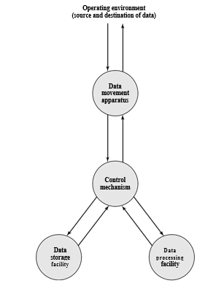
Above figure depicts the basic functions that a computer can perform. In general terms, there are four functions, namely:
- Data processing
The computer must be able to process data. The data may take a wide variety of forms, and the range of processing requirements is broad. However, we shall see that there are only a few fundamental methods or types of data processing.

- Data storage
It is also essential that a computer store data. Even if the computer is processing data on the fly (i.e., data come in and get processed, and the results go out immediately), the computer must temporarily store at least those pieces of data that are being worked on at any given moment. Thus, there is at least a short-term data storage function. Equally important, the computer performs a long-term data storage function.
- Data movement
The computer must be able to move data between itself and the outside world. The computer’s operating environment consists of devices that serve as either sources or destinations of data. When data are received from or delivered to a device that is directly connected to the computer, the process is known as input–output (I/O), and the device is referred to as a peripheral. When data are moved over longer distances, to or from a remote device, the process is known as data communications.

- Control
There must be control of these three functions. Ultimately, this control is exercised by the individual(s) who provides the computer with instructions. Within the computer, a control unit manages the computer’s resources and orchestrates the performance of its functional parts in response to those instructions.

These operations can be shown in diagram as follows:
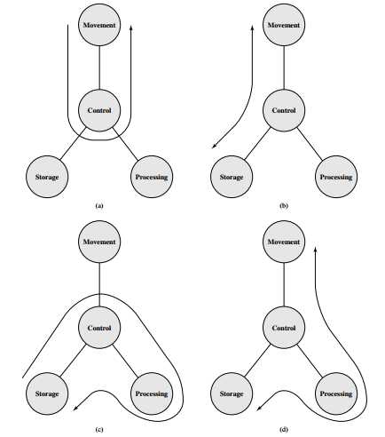

Above figure depicts the four possible types of operations. The computer can function as a data movement device (Figure a), simply transferring data from one peripheral or communications line to another. It can also function as a data storage device (Figure b), with data transferred from the external environment to computer storage (read) and vice versa (write). The final two diagrams show operations involving data processing, on data either in storage (Figure c) or en-route between storage and the external environment (Figure d).

Structure:
Figure below is the simplest possible depiction of a computer. The computer interacts in some fashion with its external environment. In general, all of its linkages to the external environment can be classified as peripheral devices or communication lines.

.

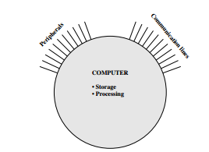

This diagram can be further expanded as follows:
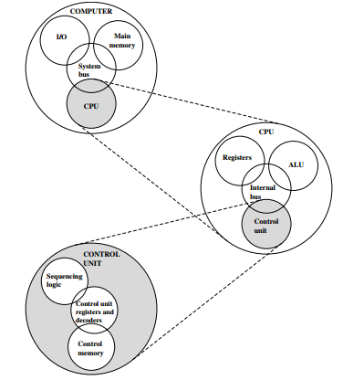
There are four main structural components:
- Central processing unit (CPU): Controls the operation of the computer and performs its data processing functions; often simply referred to as processor.

- Main memory: Stores data.

- I/O: Moves data between the computer and its external environment.

- System interconnection: Some mechanism that provides for communication among CPU, main memory, and I/O. A common example of system interconnection is by means of a system bus, consisting of a number of con-ducting wires to which all the other components attach.

Each of these components have sub components. Their major structural components are as follows:
- Control unit: Controls the operation of the CPU and hence the computer

- Arithmetic and logic unit (ALU): Performs the computer’s data processing functions

- Registers: Provides storage internal to the CPU

- CPU interconnection: Some mechanism that provides for communication among the control unit, ALU, and registers

- Discuss von Neumann computer architecture in detail.
The von Neumann architecture, also known as the von Neumann model and Princeton architecture, is a computer architecture based on that described in 1945 by the mathematician and physicist John von Neumann and. This describes a design architecture for an electronic digital computer with different parts.
There are essentially three different entities, a processing unit, an i/o unit and a storage unit. The units are connected over buses.
The processing unit can be broken down into a couple of subunits, the ALU, the processing control unit and the program counter. The ALU compute the arithmetic logic needed to run programs (adding and subtracting to registers etc.) To be simple, the control unit just controls the flow of data through the processor. It could be called the brain of the processor if you will. The program essentially points to when you are in instruction memory, it keeps track of what instruction you are running at the moment and increments when done.
The i/o unit essentially encompasses all i/o the computer could possibly do (printing to a monitor, to paper, inputs from a mouse or keyboard, etc.)
The storage unit stores anything the computer would need to store and retrieve. This includes local hard drive storage, cache storage, and ram. There are arguments as to whether instruction memory should be included here or in the processing unit.
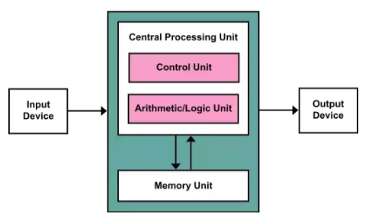
It is also called stored program computer. Here, both the instructions and the data (that the instructions operate on) are stored in the computer memory itself. Before the introduction of this idea, instructions and data were considered two totally different entities and were thus stored separately.
Thus instructions like data can be read from the memory and written to the memory by the processor.
The CPU does not distinguish in the way it deals with data or program. The read/write operations that are valid for data are valid for programming instructions as well.
Simply put the CPU addresses the memory, fetches the corresponding instruction from the memory, executes them and as per requirement addresses and then reads the data from the memory as well.
The Von Neumann Computer was the first computer to be based on the stored program concept. The architecture on which computers now are based is thus called the Von Neumann Architecture.
Von Neumann had proposed few registers in his model. They are discussed briefly below:
IR:
The instruction register (IR) is used to hold the instruction that is currently being executed. The contents of IR are available to the control unit, which generate the timing signals that control the various processing elements involved in executing the instruction.

PC:
The Program Counter is one of the most important registers in the CPU. A program is a series of instructions stored in the memory. These instructions tell the CPU exactly how to get the desired result. It is important that these instructions must be executed in a proper order to get the correct result. This sequence of instruction execution is monitored by the program counter. It keeps track of which instruction is being executed and what the next instruction will be.
SP:
Stack pointer (SP) is used to point to the top activation record on the run-time stack. The run-time stack contains one activation record for each function or procedure invocation that is currently unfinished in the program. The top activation record corresponds to the current function invocation. When a function call is made an activation record is pushed onto the run-time stack. When a function returns, the activation record is popped by decrementing the stack pointer to point to the previous activation record.
AC:
AC is one of the general purpose registers but it is specifically used to 'accumulate' the result of the currently running instructions.
MAR:
MAR are used to handle the data transfer between the main memory and the processor. The MAR holds the address of the main memory to or from which data is to be transferred.
MDR:
MDR are used to handle the data transfer between the main memory and the processor. The MDR contains the data to be written into or read from the addressed word of the main memory.
Difference between Harvard architecture and Von Neumann architecture can be tabulated as follows:

SN | Von Neumann Architecture | Harvard Architecture
1 | This has a single common memory space where both program instructions and data are stored. | Harvard architecture computers have separate memory areas for program instructions and data.
2 | There is a Single data bus which fetches data and instructions | There are two or more internal data buses which allow simultaneous access to both instructions and data.
3 | Execution time taken by the CPU to fetch a program is high. | Time for execution of program is low.
4 | The advantage is its simplicity and economy. | Its high-speed execution time is at the cost of more hardware complexity.

- Explain IAS computer architecture in detail.
In 1946, von Neumann and his colleagues started designing a new stored-program computer, referred to as the IAS computer, at the Princeton Institute for Advanced Studies. This computer is called IAS computer. It was not completed until 1952 and is the prototype of all subsequent general-purpose computers.
Figure below shows the general structure of the IAS computer. It consists of
• A main memory, which stores both data and instructions
• An arithmetic and logic unit (ALU) capable of operating on binary data
• A control unit, which interprets the instructions in memory and causes them to be executed
• Input/output (I/O) equipment operated by the control unit Main memory (M)
- Central processing unit (CPU)

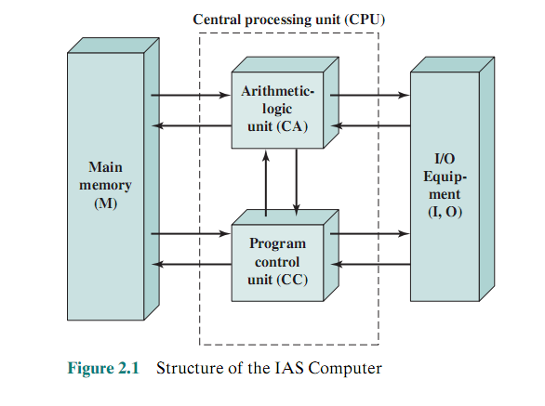

The memory of the IAS consists of 1000 storage locations, called words, of 40 binary digits (bits) each.
Both data and instructions are stored there. Numbers are represented in binary form, and each instruction is a binary code.
Figure below illustrates these formats. Each number is represented by a sign bit and a 39-bit value. A word may also contain two 20-bit instructions, with each instruction consisting of an 8-bit operation code (opcode) specifying the operation to be performed and a 12-bit address designating one of the words in memory (numbered from 0 to 999). The control unit operates the IAS by fetching instructions from memory and executing them one at a time.

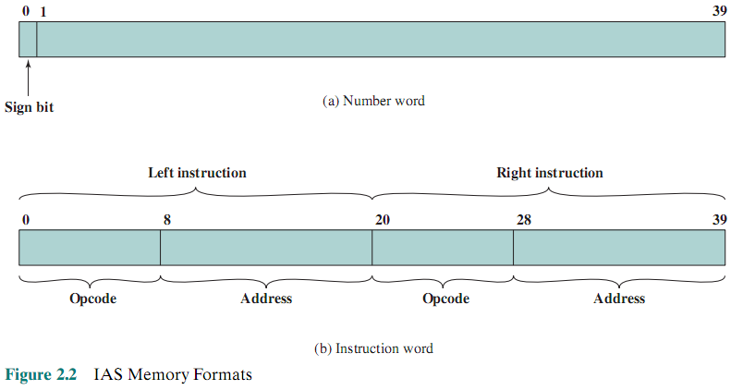
To explain this, a more detailed structure diagram is needed, as indicated in Figure below. This figure reveals that both the control unit and the ALU contain storage locations, called registers, defined as follows:
• Memory buffer register (MBR): Contains a word to be stored in memory or sent to the I/O unit, or is used to receive a word from memory or from the I/O unit.
• Memory address register (MAR): Specifies the address in memory of the word to be written from or read into the MBR.
• Instruction register (IR): Contains the 8-bit opcode instruction being executed.
• Instruction buffer register (IBR): Employed to hold temporarily the right-hand instruction from a word in memory.
• Program counter (PC): Contains the address of the next instruction pair to be fetched from memory.
• Accumulator (AC) and multiplier quotient (MQ): Employed to hold tem-porarily operands and results of ALU operations. For example, the result of multiplying two 40-bit numbers is an 80-bit number; the most significant 40 bits are stored in the AC and the least significant in the MQ.
The IAS operates by repetitively performing an instruction cycle, as shown in Figure 2.4. Each instruction cycle consists of two subcycles. During the fetch cycle, the opcode of the next instruction is loaded into the IR and the address portion is loaded into the MAR. This instruction may be taken from the IBR, or it can be obtained from memory by loading a word into the MBR, and then down to the IBR, IR, and MAR.
These operations are controlled by electronic circuitry and result in the use of data paths. To simplify the electronics, there is only one register that is used to specify the address in memory for a read or write and only one register used for the source or destination
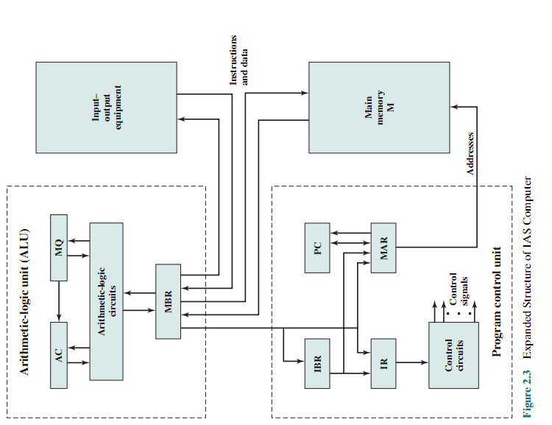
Once the opcode is in the IR, the execute cycle is performed. Control circuitry interprets the opcode and executes the instruction by sending out the appropriate control signals to cause data to be moved or an operation to be performed by the ALU.
The IAS computer had a total of 21 instructions, which can be grouped as follows:
• Data transfer: Move data between memory and ALU registers or between two ALU registers.
• Unconditional branch: Normally, the control unit executes instructions in sequence from memory. This sequence can be changed by a branch instruction,
which facilitates repetitive operations.
• Conditional branch: The branch can be made dependent on a condition, thus
allowing decision points.
• Arithmetic: Operations performed by the ALU.
• Address modify: Permits addresses to be computed in the ALU and then inserted into instructions stored in memory. This allows a program considerable addressing flexibility.
OLD QUESTIONS
- Explain the importance of execution time in a computer. Explain different types of execution times with suitable examples. Suppose B is 8 times faster than A, C is 32 times faster than A, and C is 4 times faster than B for the same programs P1 and P2. Calculate the average execution time.
- What is an Amdahl’s law? Explain it with required equation and suitable example.
- Explain in detail about the functional view of a computer with suitable example. Differentiate between architecture and organization.
- Differentiate between structure and function of a computer. Draw the block diagrams of the functional views of the computer and explain them.
- Draw the structure of an IAS and explain about each block in detail. Explain the operation of MAR and MBR with example.
- Differentiate between architecture and organization. Explain the different structures of a computer.
- Draw the block diagram of IAS structure and explain each blocks with suitable example.
- Explian in detail about the functional view of a computer with suitable example. Differentiate between architecture and organization.
- Draw the block diagram of IAS system. Explain in detail about each block with suitable example.
- Draw the block diagram of the structure of von Nuemann machine and explain each blocks with examples.

